COMPUTING SUBJECT: Restful ASP.Net Core-services with CORS

TYPE: Assignment

IDENTIFICATION: RestCustomerService No. 2

COPYRIGHT: Michael Claudius & Peter Levinsky

LEVEL: Medium

TIME CONSUMPTION: 2 hours

EXTENT: 40 lines

OBJECTIVE: Restful services based on ASP.Net Core

PRECONDITIONS: Exercise RestCustomerService No. 1 is a must
Rest service theory. Http-concepts
Computer Networks Ch. 2.2

COMMANDS:
IDENTIFICATION: RestCustomerService No. 2 /MICL&PELE

Purpose
The purpose of this assignment is to set up Unit test and to provide Cross Origin Resource Sharing (CORS) of a restful ASP.Net Core web service. More specifically to enable Cross Origin Requests in ASP.Net Core Web API 2.1.

Precondition
You must have done the RestCustomerService, as basic information and guidelines are given in this exercise.

Mission
You are to make and use restful web services based on the ASP.Net Core services by setting up a server (provider), test the services by use of Fiddler/Postman and create a client (consumer) using the services provided. On the way you will publish the service to the cloud (Azure). The service supports the classic GET, POST, PUT and DELETE requests. This we shall do in the following steps:

- Create a project with auto generated service: api/values
- Create a model class Customer for customer data
- Create a controller CustomerController to provide REST services
- Extend CustomerController with a list of customers
- Create and provide a controller oriented service in CustomerController
- Test the service using Browser/Fiddler/Postman
- Create a client/consumer utilizing the service
- More services and testing by Fiddler/Postman and client/consumer
- Publish to Azure
- Support simple Cross Origin Resource Sharing (CORS) using Azure
- Support dedicated Cross Origin Resource Sharing (CORS) in the project
- Set up a project for Unit test
- Refactor the consumer code

This assignment holds steps 11 – 13, whereas steps 1-10 were done in the previous exercise RestCustomerService No. 1.

Domain description
Management and administration of customers utilizing web services for the classic operations:

Create (POST)
Read, i.e. Find one or more. (GET)
Update (PUT)
Delete (DELETE)

Reflecting standard Http requests.

When surfing on the net it is easy to find many descriptions more or less useful, and in more or less updated versions. Here are some:

Useful links for C#:

CORS
https://docs.microsoft.com/en-us/aspnet/web-api/overview/security/enabling-cross-origin-requests-in-web-api (from the middle enable CORS)

https://docs.microsoft.com/en-us/aspnet/core/security/cors?view=aspnetcore-2.1
Probably the best description holds comparison of Middleware CORS and CORS in MVC

https://stackoverflow.com/questions/44379560/how-to-enable-cors-in-asp-net-core-webapi

https://www.nuget.org/packages/Microsoft.AspNetCore.Cors/

Test
https://code.msdn.microsoft.com/Unit-Testing-with-ASPNET-1374bc11/sourcecode?fileId=179451&pathId=1993051352

https://docs.microsoft.com/en-us/aspnet/web-api/overview/testing-and-debugging/unit-testing-with-aspnet-web-api

Assignment 11: Support Cross Origin Resource Sharing (CORS)
You must now extend your Rest Service to support CORS, so your Rest Service (API) can be consumed in scripting frontend pages, as Javascript/Typescript based application.
In the following we use the Middleware approach; i.e. the rules/policies will be valid for the whole application service (all controllers and all methods follow the rules).
In Appendix B another approach MVC is described.

- First you need to install NuGet-package, Microsoft.AspNetCore.Cors (2.1.1)-
Remember to use the version that fits the your Asp.Net version! Otherwise an error will be given.
(You can also use Microsoft.AspNet.WebApi.Cors, originally made for EntityFramework).
In your project open the NuGet manager and choose the package to be installed:
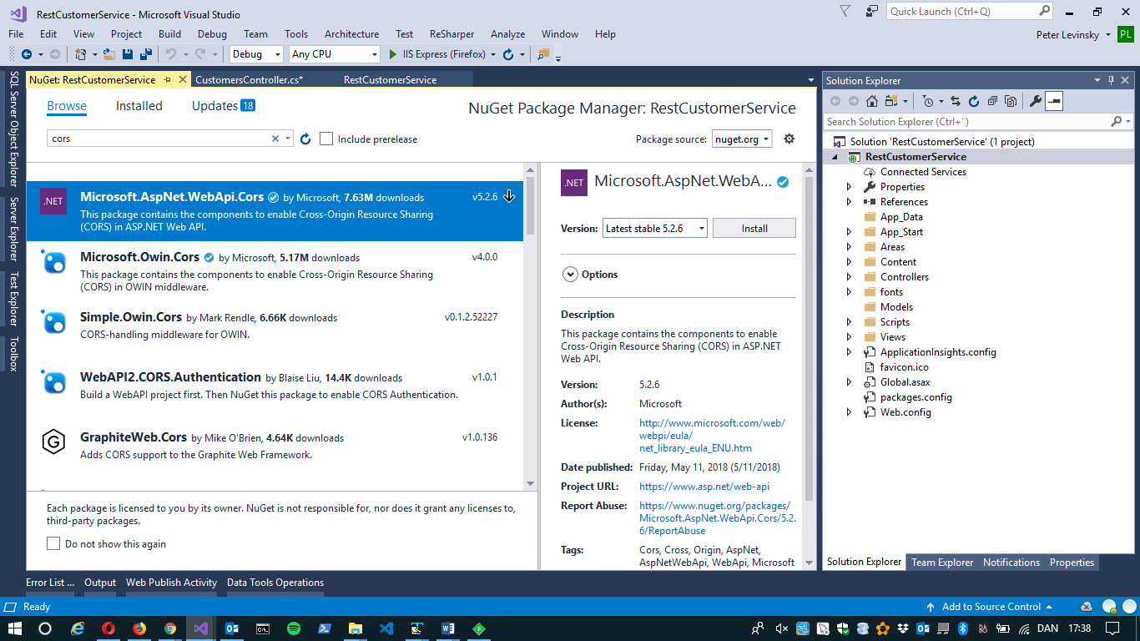

and yes … It takes a little time…..
- In the solution (Solution Explorer) open the file Startup.cs.
In the ConfigureServices method, add the line

services.AddCors();

- Still in the class, Startup.cs.
In the Configure-method, before the app.UseMvc() call, add the lines:

app.UseCors(
options =>
{options.AllowAnyOrigin().AllowAnyMethod();
// allow everything from anywhere
});

We are now ready to test the new project by setting up a Preflight Request using Fiddler/Postman.

- Try to send a Preflight Request from Fiddler/Postman
Be aware that you must:
- Click on Composer
- Choose OPTIONS
- Define the Content-Type: application/json
- Define Origin: easj.dk //or similar
- Define Access-Control-Request-Method: ANY or GET, POST, PUT //or more

It will look something like this:

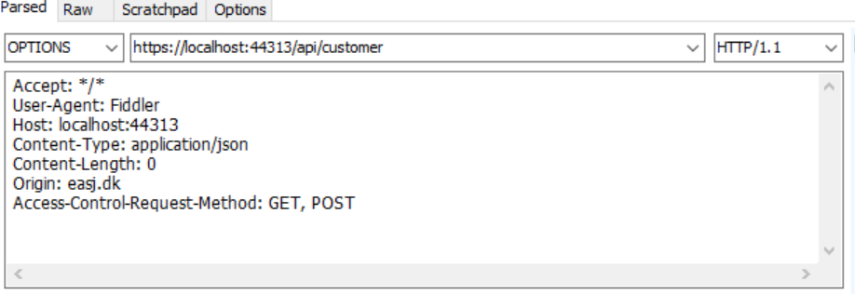

Clicck on Execute and hopefully the Response will look something like this:
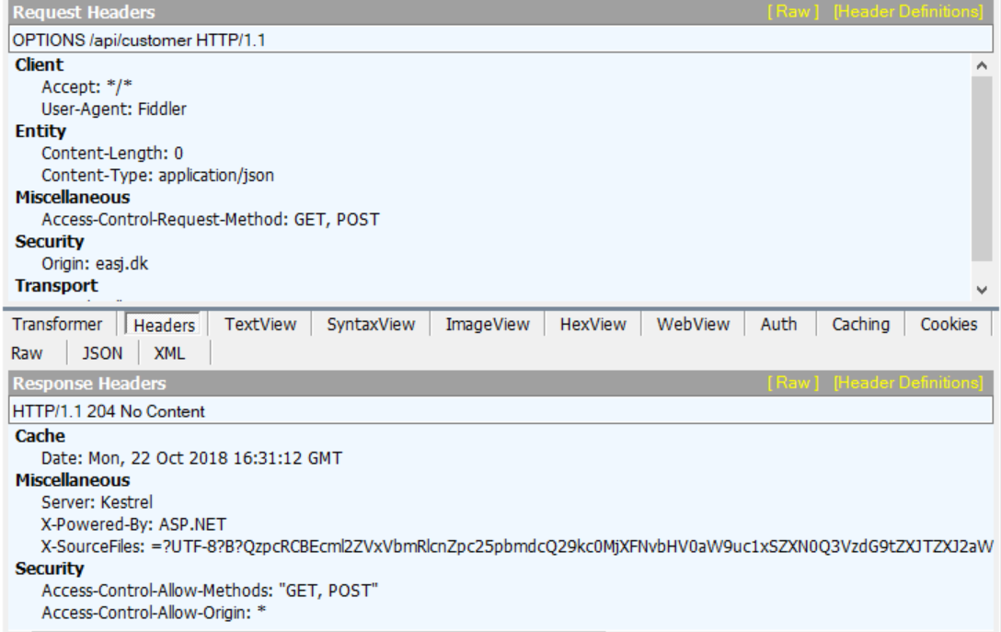

Notice the Security: Access-Controls- answers. This means the service is ready for communication with the client (Javascript/Typescript/Fiddler etc.)

- Now try to invoke the methods GET, POST etc. from Fiddler.
- Publish your service in Azure in a new Web-App and also set up a Preflight Request similar as the one for Localhost.
Unfortunately you probably get a 301/502 error security error.
Why?
The issue is that if your project was created it was configured for Https and Fiddler uses Http-scheme for Azure. Read on…

- Go to your Azure Portal
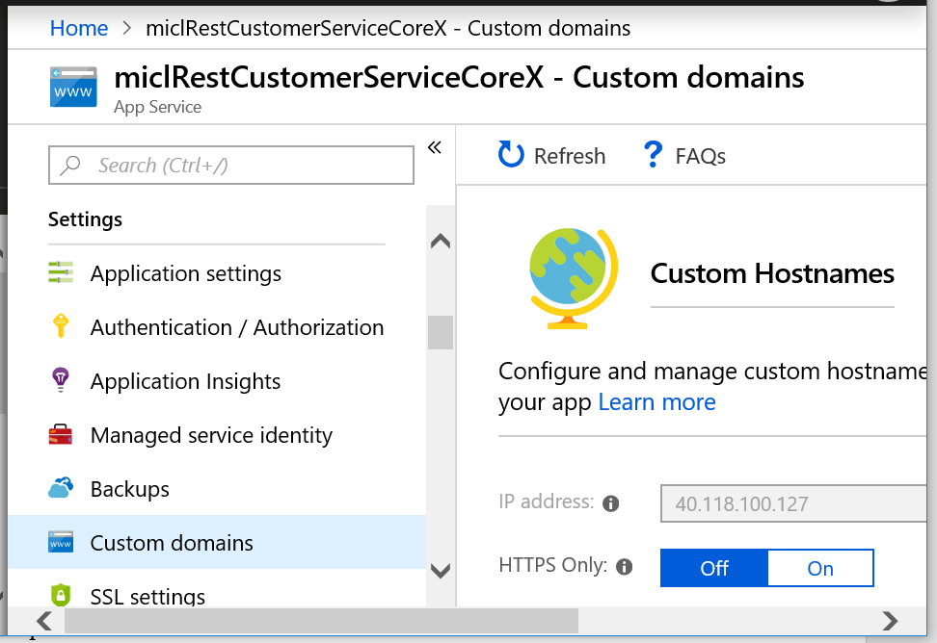
  - Open your Web-App project
  - Find Custom domains in the
left scroll-bar
  - Set Https-Only to OFF
  - Click Refresh

- Now set up a Preflight Request similar as the one for Localhost.
Finally try to invoke the methods GET, POST etc. from Fiddler.

DONE !!
Assignment 12: Testing your REST service
To be sure that your REST service are working correctly, you make a component test (Unit test) of the controller.
When testing you first create a test-project, then implement the test methods and finally run the test.
- In your solution you have to create a new project for testing purpose.
In your solution right-click to add a new project.
Choose Test and then pick MSTest test project (.Net core) and give it a name e.g.: RestCustomerServiceTest.

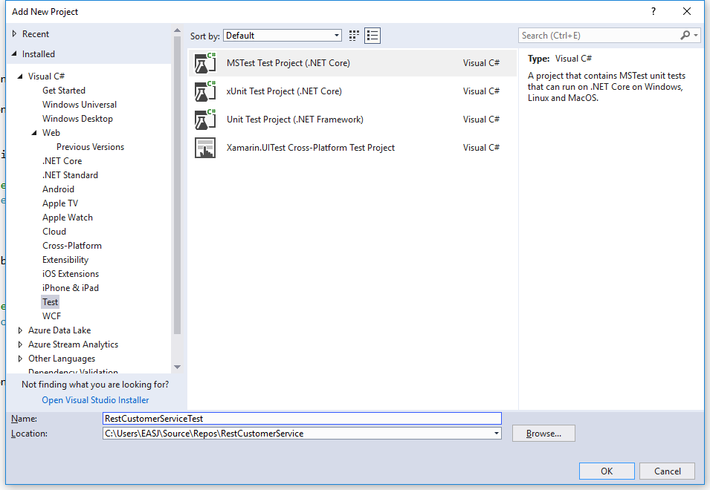

Before implementing the test methods, you need two steps:
  - Let your Test-project refer to your Rest-project i.e. at the dependencies right-click and add a reference to the rest-project in your ‘Projects’.
  - To your Test-project add a NuGet package, browse for ‘mvc.core’ choose Microsoft.AspNetCore.Mvc.Core.
IF you later are making a test on a Rest-project utilizing a database you might also need System.Data.SQLClient.
Maybe not be necessary IF you have clicked and accepted all Updates in NuGet.
.
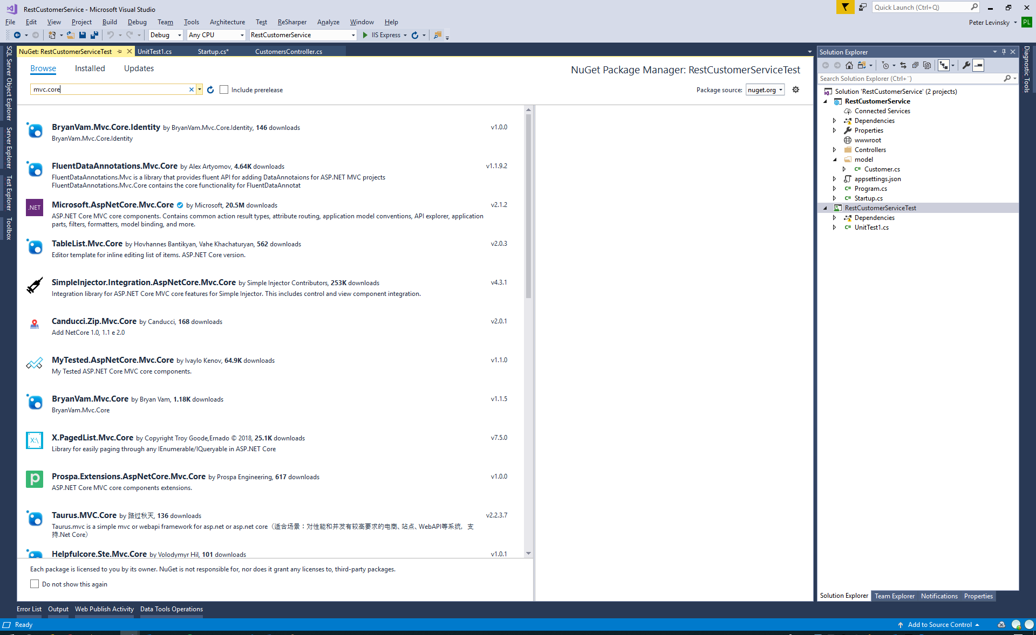

- Implement your Test Methods by instantiate an object of your CustomerController and call some methods and assert the result.

- Run your Test by right-click and run Test.

Assignment 13: Refactor the consumer code
Refactoring is about making the code either smarter (faster, better overview, library usage) or downsizing the number of code lines!
Take a look at your consumer code.
Its messy and a lot of stuff in one sequence…. A more structured approach and program is beneficial.
Can you do something about it?!

CONGRATULATIONS YOU NOW HAVE A PROFFESIONAL RESTFUL WEB SERVICE
Now you and others can later utilize your rest service from Typescript/Javascript etc..

Appendix A: Running from Fiddler/Postman
This a is an example for using a service add on two integers. It will be similar for services on customers.
Try to invoke the method from Fiddler/Postman
Be aware that you must:
- Click on Composer
- Choose POST
- Define the Content-Type: application/json
- Request body must hold the Customer as a Json-string

It will look something like this:
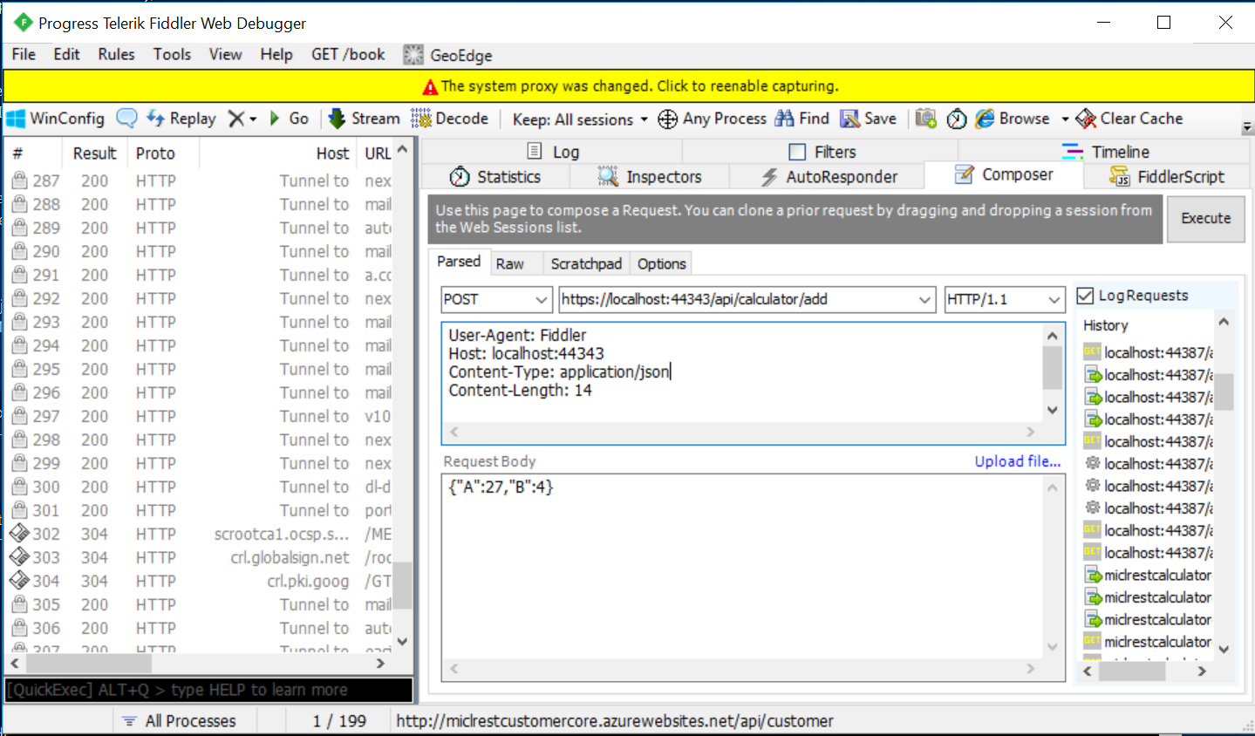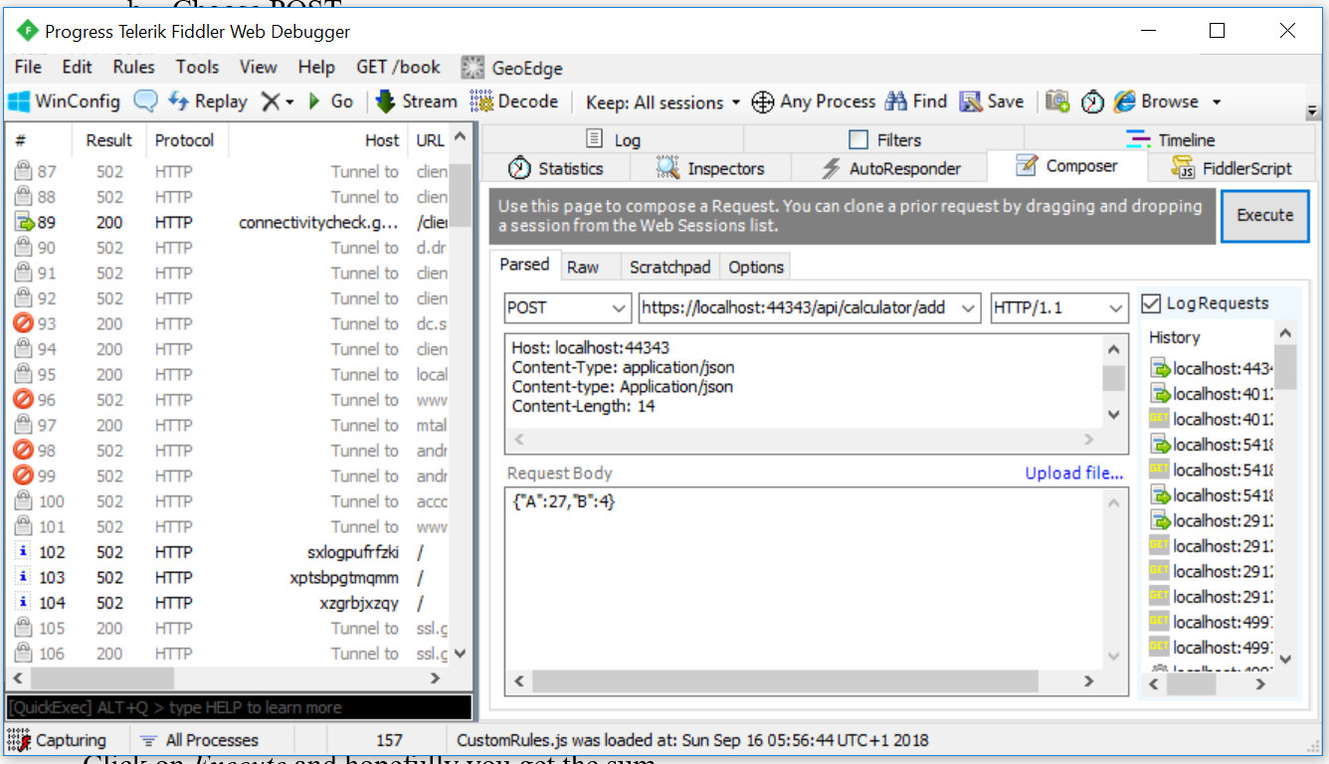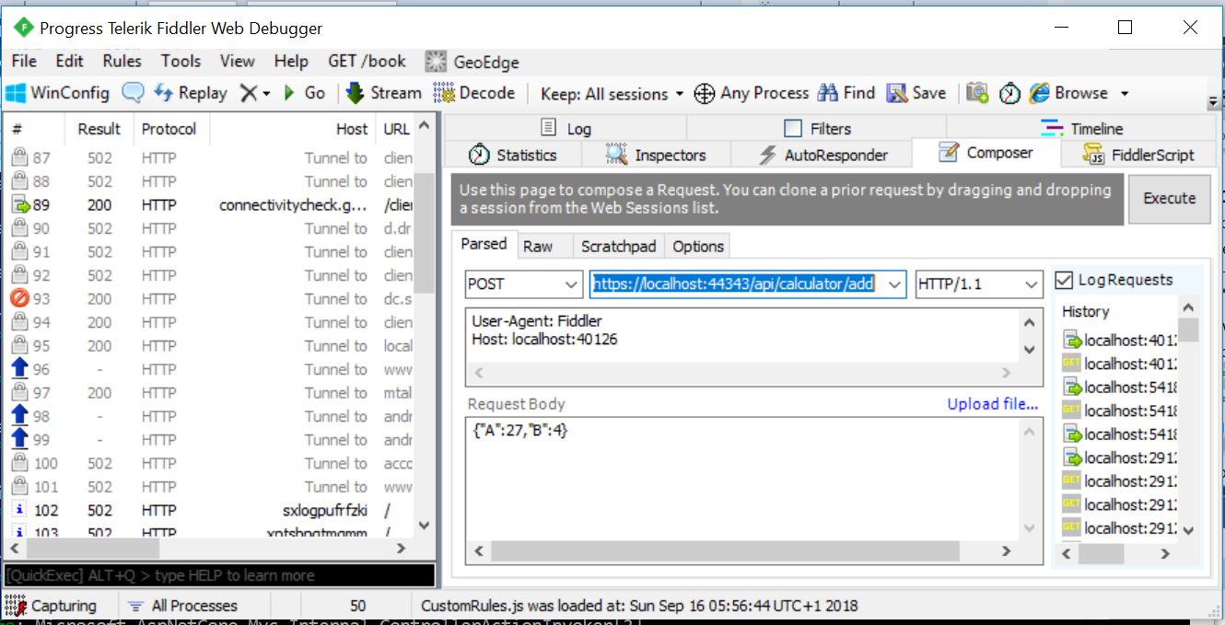

Click on Execute and hopefully you get the sum.

Appendix B: MVC CORS
This section describes how to extend your Rest Service to support CORS, so your Rest Service (API) can be consumed in scripting frontend pages, as Javascript/Typescript based application.
In the following we use the MVC approach; i.e. the rules/policies are specific for each controller and each method.

- First you need to install NuGet-package, Microsoft.AspNet.Core.Cors.
In your project open the NuGet manager and choose the package to be installed:

and yes … It takes a little time…..
- In the solution (Solution Explorer) open the file Startup.cs.
In the ConfigureServices method, add various policies like:

services.AddCors(options =>
{
options.AddPolicy("AllowSpecificOrigin",
builder => builder.WithOrigins("http://example.com"));

options.AddPolicy("AllowAnyOrigin",
builder => builder.AllowAnyOrigin());
options.AddPolicy("AllowAnyOriginGetPost",
builder => builder.AllowAnyOrigin().WithMethods("GET", "POST"));
});

- In the controller, CustomerController, specify the policy you want on the controller itself, like:

[Route("api/[controller]")]
[EnableCors("AllowAnyOrigin")]
[ApiController]

Still the controller, specify the policy for the methods, suppressing the controller-policy.

[HttpDelete("{id}")]
// no policy i.e. inherits the controller policy

[HttpPost]
[EnableCors("AllowSpecifOrigin")]

[HttpGet]
[DisableCors] //disable the controller policy

We are now ready to test the new project by setting up a Preflight Request using Fiddler/Postman.

- Just follow the Preflight guideline from assignment 11 d-h.
Check if the different policies actually work…?!!
Investigate more by yourself.

